Hood Lift Kit Installation Instructions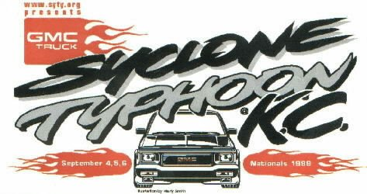

When I worked on my trucks, I hated the steel prop rod that held up the stock steel hood. It was always in the way. I hated it so much that I designed a kit to install gas struts to support the stock steel hood on any 1982-1993, S10 based truck, including Syclones, Typhoons and Bravadas. Also works on the Goodmark hoods.

The brackets for this kit are unique to our trucks. The gas struts that I use have lasted for 7 years (on my trucks). The lower brackets bolt on using existing holes and the upper brackets are installed with two or three screws (included). The struts simply snap onto the brackets and you are in business. The hood is at the same approximate height as when the prop rod was used.

The kit consists of two gas struts, 4 strut locks, two upper brackets, a passenger side lower bracket, driver’s side bracket and screws

Tools required: Drill with a screwdriver bit, drill bits, 3/8” wrench, screwdriver, tape measure.

Installation:

First, read the instructions.

Next, lay out all of the parts. The two lower brackets are larger. The upper brackets are smaller.

Install the drivers side lower bracket, using the enclosed nut and bolt. Align the bracket under the hole that is in the lip of the driver’s side fender (13 inches from the firewall). Insert the bolt from the top and attach the nut from the bottom. You may need to grind off a little metal (production differences) Tighten this nut and bolt securely. This will place the bracket behind the windshield washer tank. The “stud” will be pointing toward the engine.

Install the passenger side bracket, same as above. The bracket will tuck behind the factory Engine Coolant Overflow tank, or a Kenne Bell Rear Mount air cleaner assembly. There should be plenty of clearance. If not, contact me for a set of custom brackets.

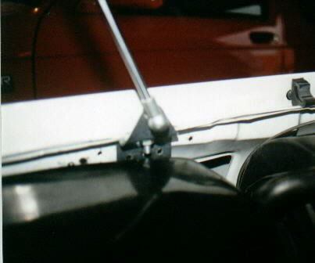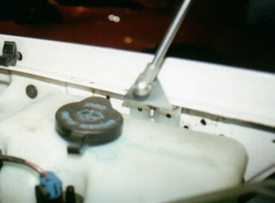

Passenger side lower bracket Driver’s side lower bracket

The next step is to mount the upper brackets. Both brackets will mount with the “stud” pointing toward the fender.

Measure 25.5” from the base of the hood. There is a rectangular mounting pad on the underside of the hood on each side at this location. Mark this distance with a line. Hold the bracket up to the mounting pad and place the bottom edge of the bracket on this line. (The stud points toward the fender). With the tape measure, measure 1 3/4” from the outside edge of the hood to the bracket. This will place the outside edge of the stud 1” from the edge of the hood. Mark this location also. Mark the Holes. This will place the strut mounting stud 26.5” from the base of the hood.

Passenger side upper bracket Drivers side upper bracket
(Bottom View) (Side View)
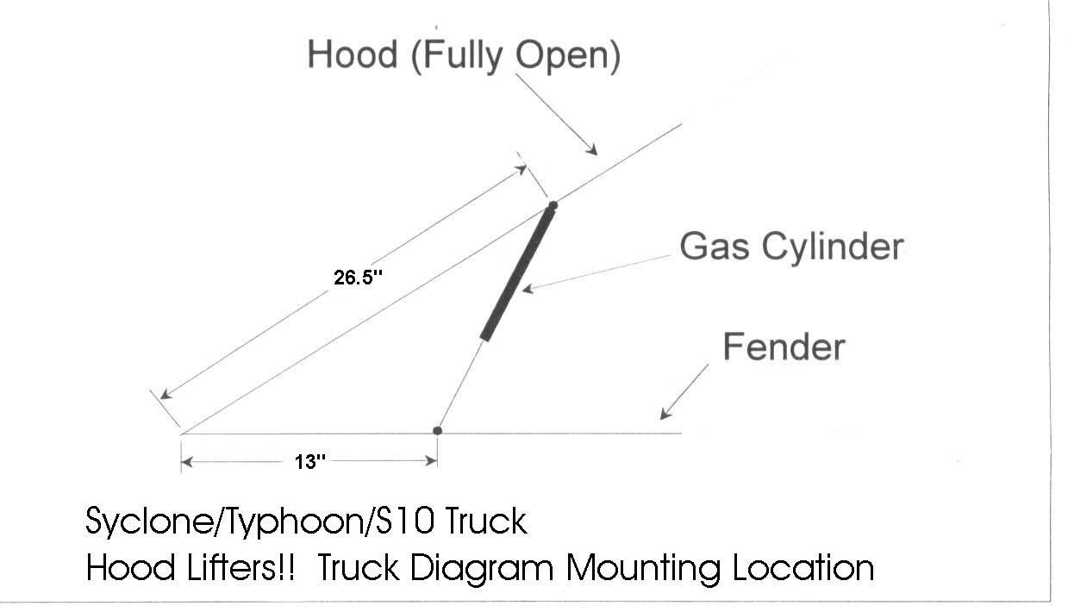

There are three mounting options:

- Mark the holes and move the bracket. Drill small pilot holes and then replace the bracket and attach with the screws with either a:
- Nutdriver
- Screwdriver
- Drill with a driver bit

- Use option A and instead of screws, use Steel pop rivets (not included).

C. Use ¼” x ¾” Self-tapping screws to mount the upper bracket.

You can also use double-sided tape to hold the upper brackets in place prior to attaching them with screws

Once the upper brackets are in place and secured to the hood (do not overtighten!!), the snap the struts onto the brackets. Install the struts, “upside” down. That is with the larger diameter portion on the top and the steel shaft pointing downward.

Secure the struts to the mounting studs with the locking clips. (provided in the bag with the screws)

